29.47: a) 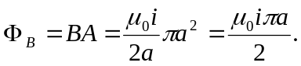
b) 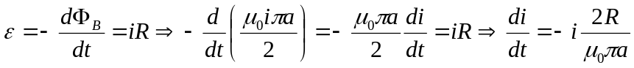
c) Solving 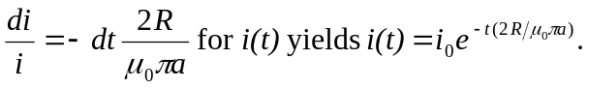
d) We want
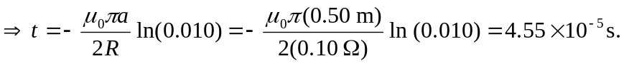
e) We can ignore the self-induced currents because it takes only a very short time for them to die out.

